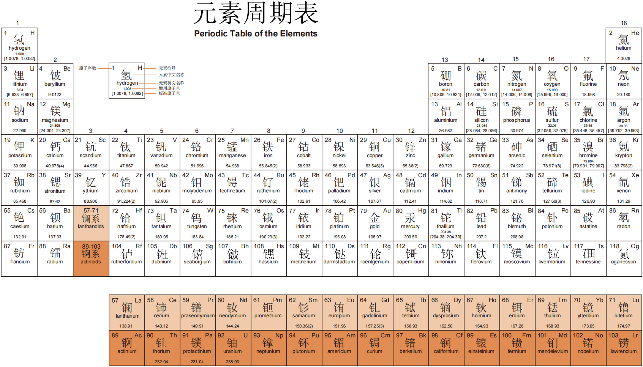

Part A: Multiple choice (Select the one that is best in each case. 2 point/question)
1. When the following equation is balanced, the coefficients are ________.

C₈H₁₈ + O₂ → CO₂ + H₂O

A) 2, 3, 4, 4

B) 1, 4, 8, 9

C) 2, 12, 8, 9

D) 4, 4, 32, 36

E) 2, 25, 16, 18

2. Of the reactions below, which one is not a combination reaction?

A) C + O₂ → CO₂

B) 2 Mg + O₂ → 2 MgO

C) 2 N₂ + 3 H₂ → 2 NH₃

D) CaO + H₂O → Ca(OH)₂

E) 2 CH₄ + 4 O₂ → 2 CO₂ + 4 H₂O

3. A nitrogen oxide (氮氧化物) is 63.65% by mass nitrogen. The molecular formula could be ________.

A) NO B) NO₂ C) N₂O D) N₂O₄ E) either NO₂ or N₂O₄
4. A compound is composed of element X and hydrogen. Analysis shows the compound to be 80% X by mass, with three times as many hydrogen atoms as X atoms per molecule. Which element is element X?

A) He B) C C) F D) S E) none of these
5. How many molecules of ammonia (NH₃) are present in 6.9 g of ammonia?
A) 0.41 B) 41 C) 8.3 × 10²³ D) 4.2 × 10²⁴ E) 2.4 × 10²³

6. The number with the most significant (有效位) zeros is ________.
A) 0.00002510
B) 0.02500001
C) 250000001
D) 2.501 × 10⁻⁷
E) 2.5100000

7. In the reaction
2 A + 3 B → C
4.0 mol A react with 4.0 mol B. Which reactant is limiting?
A) A is limiting because there are 2 mol of it but 4.0 mol are needed.
B) B is limiting because there are 4.0 mol of it but 6.0 mol are needed.
C) A is limiting because 2 is smaller than 3 (the coefficients in the balanced equation).
D) Neither is limiting because equal amounts (4.0 mol) of each reactant are used.
E) B is limiting because 3 is larger than 2 (the coefficients in the balanced equation).

8. The correct answer (reported to the proper number of significant figures) to the following is ________.

(12.67 + 19.2)(3.99) / (1.36 + 11.366) = ________

- 9.9922 B) 9.992 C) 9.99 D) 1.00 × 10¹ E) none of the above

9. Which of the following are nonelectrolytes in water?
(i) HF
(ii) ethanol, C₂H₅OH
(iii) C₁₂H₂₂O₁₁
(iv) KClO₃
(v) Cu(NO₃)₂
A. (iii) B. (ii) and (iii) C. (i), (ii), and (iii) D. (i), (iv), and (v) E. (ii)

10. Indicate the correct net ionic equation for the reaction of Na₂SO₃(s) and HCl(aq).
A) Na₂SO₃(s) + 2Cl⁻(aq) → 2NaCl(aq) + SO₃²⁻(aq)
B) SO₃²⁻(aq) + 2HCl(aq) → 2Cl⁻(aq) + SO₂ (g)+ H₂O(l)
C) Na₂SO₃(s) + 2HCl(aq) → 2NaCl(aq) + SO₂ (g) + 2H₂O(l)
D) Na₂SO₃(s) + 2H⁺(aq) → 2Na⁺(aq) + SO₂ (g) + H₂O(l)
E) SO₃²⁻(aq) + 2H⁺(aq) → SO₂ (g) + H₂O(l)
11. A set of aqueous (水) solutions are prepared containing different acids at the same concentration: acetic acid (CH₃COOH), chloric acid (HCl) and hydrobromic acid (HBr). Which solution(s) are the most electrically conductive (电导性)?
A. both chloric acid and hydrobromic acid
B. chloric acid
C. all three solutions have the same electrical conductivity
D. acetic acid
E. hydrobromic acid

12. The reaction between strontium hydroxide (Sr(OH)₂) and chloric acid produces ________.
A. a molecular compound and a weak electrolyte
B. two weak electrolytes
C. two strong electrolytes
D. a molecular compound and a strong electrolyte
E. two molecular compounds

13. Oxidation is the ________ and reduction is the ________.
A. gain of oxygen, loss of electrons
B. loss of oxygen, gain of electrons
C. loss of electrons, gain of electrons
D. gain of oxygen, loss of mass
E. gain of electrons, loss of electrons

14. Which reactions will not produce a precipitate (沉淀) from aqueous solution?
A. AgNO₃ + KI
B. FeSO₄ + Ba(OH)₂
C. Pb(NO₃)₂ + Na₂CO₃
D. ZnCl₂ + (NH₄)₂S
E. NaBr + Al₂(SO₄)₂

15. The minerals chalcocite (Cu₂S) and malachite (Cu₂CO₃(OH)₂) are two primary sources of copper. What is the oxidation state of copper in each of these minerals?
A. +1, +2 B. +2, +1 C. +2, +2 D. +1, +1 E. +2, +4

16. What color of visible light has the longest wavelength?
A) blue B) violet (紫) C) red D) yellow E) green

17. All of the ________ have a valence shell (价壳层) electron configuration ns¹.
A) noble gases, 稀有气体
B) halogens, 卤素
C) chalcogens, 硫族
D) alkali metals, 碱金属
E) alkaline earth metals, 碱土金属

18. Which one of the following is an incorrect subshell notation?
A) 4f B) 2d C) 3s D) 2p E) 3d

19. Of the following transitions in the Bohr hydrogen atom, the ________ transition results in the emission of the lowest-energy photon (发射能量最低的光子).
A) n = 1 → n = 6
B) n = 6 → n = 1
C) n = 1 → n = 4
D) n = 3 → n = 6
E) n = 6 → n = 3

- An electron cannot have the quantum numbers n = ____, l = ____, m_{l} = ____.
- 2, 0, 0 B) 2, 1, –1 C) 3, 1, –1 D) 1, 1, 0 E) 3, 2, 1

21. Which quantum numbers must be the same for the orbitals that they designate to be degenerate (简并) in a many-electron system (such as oxygen)?
A) n, l, and m_{l} B) n and l C) l and m_{l} D) m_{l} only E) n only

22. The n = 1 shell contains ____ p orbitals. All the other shells contain ___ p orbitals.
A) 3, 6 B) 0, 3 C) 6, 2 D) 3, 3 E) 0, 6

23. A mole of red photons of wavelength 725 nm has ________ kJ of energy.
- 6.05 × 10^{–3} B) 165 C) 4.56 × 10^{–46} D) 2.74 × 10^{–19} E) 227

24. The lowest energy shell that contains d orbitals is the shell with n = ________.
A) 3 B) 2 C) 4 D) 1 E) 5

25. The 3p subshell in the ground state of atomic xenon (Xe) contains ____ electrons.
A) 2 B) 6 C) 8 D) 10 E) 36

26. Which electron configuration denotes an atom in its ground state?
A)
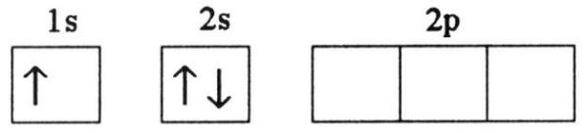
B)
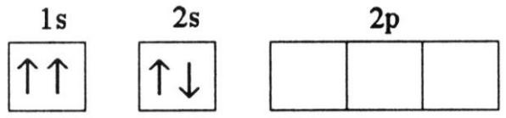
C)
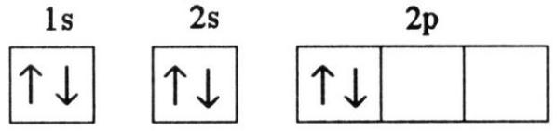
D)
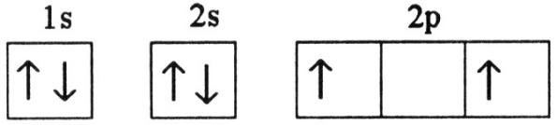
E)
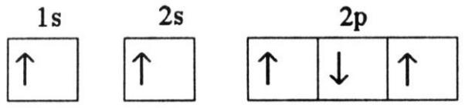

Part B: Short Answer (Write legibly and show all work for all steps in the problem)

27. (8 points) Propane (C₃H₈) reacts with oxygen in the air to produce carbon dioxide (CO₂) and water. In a particular experiment, 38.0 g carbon dioxide are produced from the reaction of 22.05 g propane with excess (过量) oxygen. What is the % yield in this reaction?
The balanced equation is C₃H₈ + 5 O₂ → 3 CO₂ + 4 H₂O
Moles C₃H₈ = 22.05 g / (44.10 g/mol) = 0.5000 mol
Theoretical yield of CO₂ = 0.5000 mol × 3 × 44.01 g/mol = 66.02 g
Percent yield = 38.0 g / (66.02 g) × 100% = 57.6%

有效数字不对扣1分，最后一位有误差不扣分

28. (8 points) Using solubility guidelines, classify the following compounds as soluble or insoluble in water: (a) cobalt(II) hydroxide (Co(OH)₂), (b) barium nitrate (Ba(NO₃)₂), (c) ammonium phosphate ((NH₄)₃PO₄), (d) Iron(II) carbonate (FeCO₃)

(a) insoluble, (b) soluble, (c) soluble, (d) insoluble

29. (8 points) Consider solutions in which 0.1 mol of each of the following compounds is dissolved in 1L of water: Ca(NO₃)₂ (calcium nitrate), C₆H₁₂O₆ (glucose, 葡萄糖), NaCH₃COO (sodium acetate), and CH₃COOH (acetic acid). Rank the solutions in order of increasing electrical conductivity, knowing that the greater the number of ions in solution, the greater the conductivity.

C₆H₁₂O₆(glucose)<CH₃COOH(acetic acid)<NaCH₃COO(sodium acetate)<Ca(NO₃)₂(calcium nitrate)

30. (12 points) (a) You have a stock solution of 14.8 M NH₃. How many milliliters (mL) of this solution should you dilute to make 1000.0 mL of 0.250 M NH₃? (b) If you take a 10.0-mL portion of the stock solution and dilute it to a total volume of 0.500 L, what will be the concentration of the final solution?

(a) V=1000.0 mL×0.250M÷14.8M= 16.9 mL
You need 16.9 mL stock solution of 14.8M NH₃.
(b) molarity = 10.0mL×14.8M÷(0.500L×1000mL/1L)= 0.296 M
The concentration of the final solution will be 0.296 M.

31. (12 points) Write the condensed electron configurations (即原子实, 如[He], [Ne], [Ar]等) and indicate the number of unpaired electrons for the following atoms in their ground states: (a) Si (element 14), (b) Cr (element 24), (c) Hg (element 80).

 | Condensed electron configurations | Number of unpaired electrons
- Si | [Ne]3s²p² | 2
- Cr | [Ar]4s¹3d⁵ | 6
- Hg | [Xe]6s²4f¹⁴5d¹⁰ | 0

草稿纸

草稿纸

